Endangered Species Status Tracker

Team Members:
Prathamesh Sonawane (u1527376@utah.edu) | UID: u1527376
Rupa Gudur (u1527938@utah.edu) | UID: u1527938
Hrishikesh Verma (u1529305@utah.edu) | UID: u1529305

Repository Link: dataviscourse2024/group-project-extinct-animal-tracker: group-project-extinct-animal-tracker created by GitHub Classroom

Background and Motivation
"Be kind to animals, great and small, for they deserve our care, one and all". Animals, the most significant aspect of our life, are disappearing from the planet we live in today. Is it our fault? How are they being put in danger? How can we help them to survive? are a few of the queries that our visualization project, "Endangered Species," would try to address. The purpose of this initiative is to raise public awareness of animal welfare issues and the causes underlying them. Many species are on the verge of extinction due to habitat destruction, climate change and pollution. Loss of animals eventually hamper the food chain and affects the entire system negatively. According to the IUCN Red List, more than 41,000 species are now at risk of extinction, with this number increasing daily.

Project Objectives
The primary goal of this project is to create an interactive, web-based tool that visually tracks and highlights the conservation status of endangered species worldwide. This tool will offer users the ability to explore species data in an intuitive, engaging manner, providing insights into the factors driving species endangerment and the global patterns of biodiversity loss. By utilizing data from credible sources such as the IUCN Red List, the project aims to provide a platform where users can explore the current state of species under threat, understand the causes behind their endangerment, and track changes in their conservation status over time.
Key questions that can be answered:
1) What species are currently at the highest risk of extinction?
2) What are the common causes of the endangerment of the species?
3) How have endangered species changed through time?
4) Which areas are the most impacted?
5) What steps have been taken, or are being taken, to safeguard these species, and how successful are they?

We want to provide a tool that is not just a central source of information but also identifies important patterns in biodiversity. Users will be better able to understand the endangered animals and their way of life through the visualization. It helps to identify both the most impacted places and the methods by which we may mitigate them.

DATA
We will source our data from reliable and reputable databases such as:
a) IUCN Red List: https://www.iucnredlist.org/en
b) WWF: https://www.worldwildlife.org/
c) GBIF: https://www.gbif.org/
d) Government Databases from wildlife departments
e) Public APIs that offer up-to-date species data
These datasets provide comprehensive information on species status, population trends, habitats, and conservation efforts.

DATA PROCESSING:
We expect to perform significant data cleaning, especially to unify different formats, remove missing entries, and remove or resolve any inconsistencies. The following steps will be involved in data processing:
- Data Cleaning: Ensure consistency in species names, habitats, and conservation statuses across different datasets.
- Data Derivation: Extract relevant attributes like population trends (increasing/decreasing), geographic range, and threats.
- Data Processing Techniques:
  - Use Python or R to clean and process data.
  - Standardize data for visualization by mapping species to specific geographic regions.
  - Aggregate population trends over time for time-series analysis.

Visualization Design
1
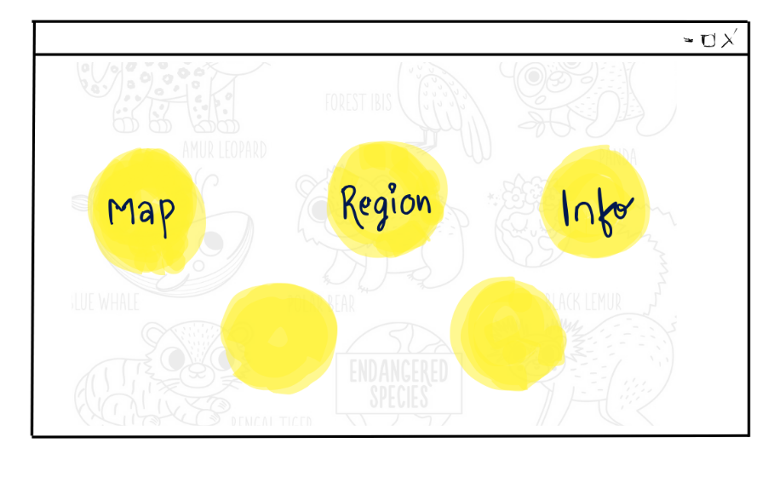
The above design is a simplified GUI of the web application. There are three buttons labelled as ‘Map’, ‘Region’ and ‘Info’ enclosed in a yellow circle. The background contains faint sketches of animals and text indicating “Endangered Species,” suggesting the application might be related to wildlife, conservation, or geographic information.

2
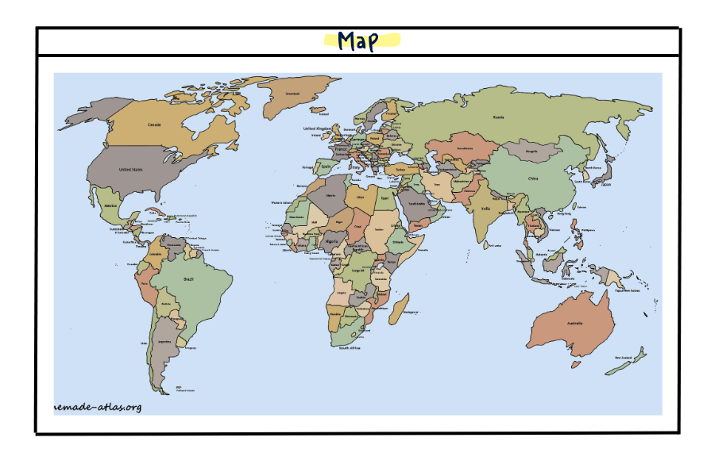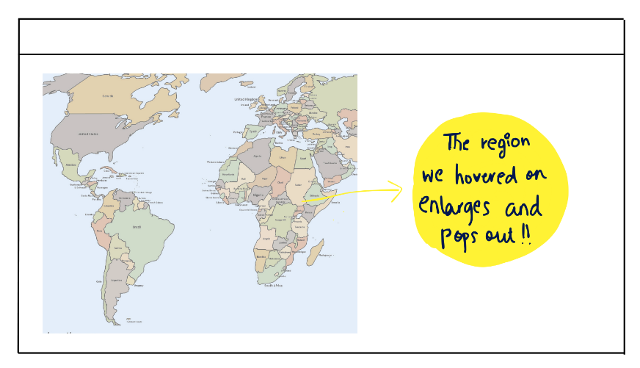

Above images show that when we click on the ‘Map’ button, we get the world map. On any given area we move the cursor to, the region enlarges and pops out that makes it an interactive visualization.

3
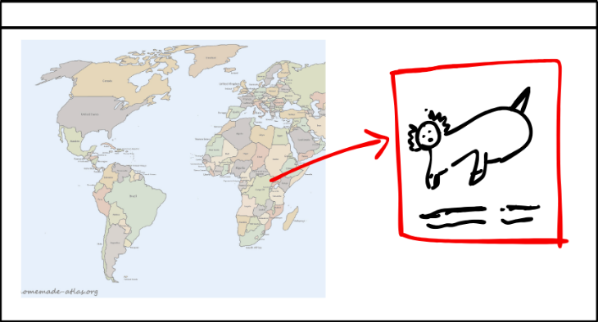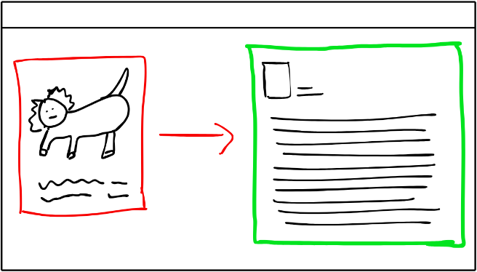

Image 3 shows the animal card after hovering on the region. If we want to learn more about the extinct/about to extinct animal on the card, just click on it for additional information.

4
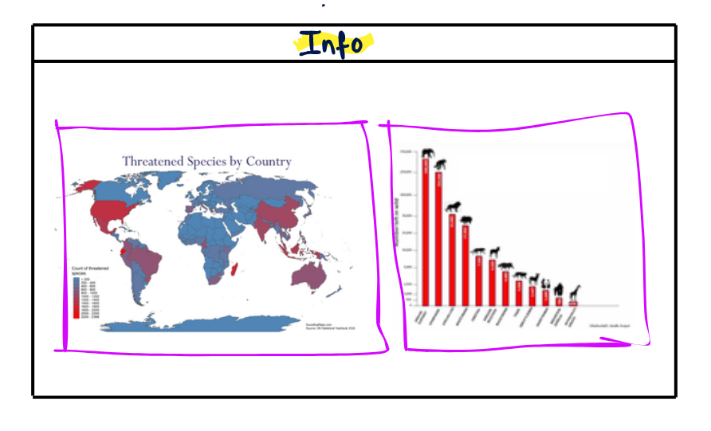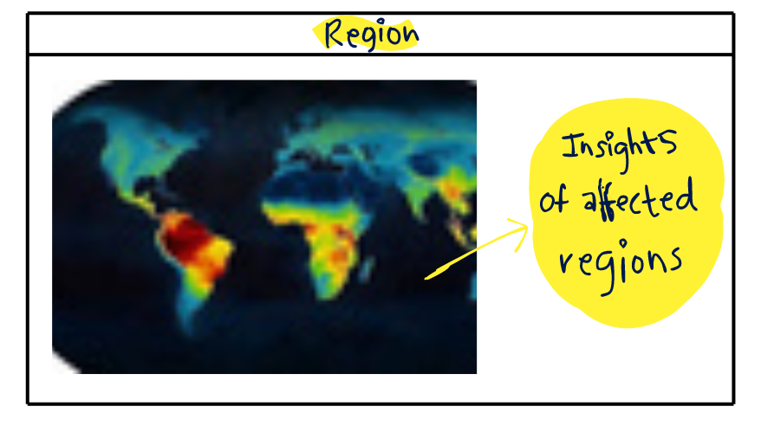

Above images show the infographics of region with most extinction cases. We are thinking to visualize it using a heat map. So region with red or darker color would represent the most extinct animal region and the lighter ones would represent less extinct region. We are also thinking about using a bar graph to represent the time-series pattern of extinction over the years.

Must-Have Features

Features without which this project would be a complete failure:
1) Interactive Map: Displays species statuses geographically with filtering options.
2) Species Population Timeline: Time-series data on how species’ populations have changed.
3) Search Functionality: Allow users to search for species or geographic locations.
4) Basic Information on Species: When a user clicks on a species, it should show key details (e.g., habitat, threats).
5) Heat Map: Displays a heat map where dark coloured region would be the most extinct species region and light coloured region would be the least.

Optional Features
Non-critical features that would be nice to have.
1) User-Generated Insights: Allow users to contribute observations or comments on specific species.
2) Mobile Optimization: Ensure the tracker works well on mobile devices.
3) Predictive Analytics: Incorporate predictions on future conservation statuses based on population trends.
4) Data Export: Allow users to download datasets for further analysis.

Project Schedule

Week 1:
- Set up project repository and gather data sources.
- Begin data cleaning and exploration for accurate data.
Week 2:
- Finalize visualization design (map and timeline view).
- Start implementing the front-end (HTML, CSS, JavaScript).
Week 3:
- Develop map visualization using Chart.js or D3 .
- Integrate time-series charts for extinction over the years.
Week 4:
- Implement search and filtering functionality.
- Test with real-world data from sources such as IUCN and GBIF.
Week 5:
- Refine visualizations, ensure interactivity and usability.
- Add optional features such as user feedback, mobile optimization, etc if time permits.
Week 6:
- Conduct usability tests and gather feedback.
- Finalize and prepare for project submission.

